RB RAIL AS

(CONTENT FOR) Request for Proposal
For Defining an It Strategy
Contents
1. INTRODUCTION 2
1.1 Background Information 2
1.1.1 Glossary 2
1.1.2 Company Overview 4
1.1.3 Project Overview 5
1.2 RFP Purpose 6
1.3 Objectives 7
2. PROJECT SCOPE 8
2.1. Scope of Work 8
2.2. Benchmarking and Best Practice 11
2.3. Collaborative Working 11
2.4. Architecture Vision 12
2.5. Baseline (As-Is) Architecture 13
2.5.1. As-Is Technology Architecture – RB Rail AS 13
2.5.2. As-Is Technology Architecture – IBs 14
2.6. Transitional and Target Architectures 14
2.7. Business Architecture 15
2.8. Data Architecture 17
2.9. Application Architecture 18
2.10. Integration Architecture 19
2.10.1. Internal Integration 19
2.10.2. External Integration 19
2.10.3. Handover Integration 20
2.11. Technology Architecture 20
2.11.1. Data centre and hosting services 20
2.11.2. Communications network 20
2.12. Security Architecture 21
2.13. IT Strategy Roadmap and Plan 22
2.14. Governance Framework 23
3. PROJECT DELIVERY APPROACH 24
3.1. Outputs and Results 24
3.2. Summary of Deliverables 24
3.2.1. General Deliverables 24
3.2.2. Cyber Security Strategy 27
3.2.3. Digitalisation Strategy 27
3.2.4. Data and Tools Strategy 27
3.2.5. Interdependencies with CCS/ENE projects 28
APPENDIX 1 Business process definition 29
APPENDIX 2 Indicative CCS subsystems 31

INTRODUCTION

Background Information

Glossary

Abbreviation or phrase | Definition
5G | The fifth-generation technology standard for broadband cellular networks
ADM | Architecture Development Method
Beneficiary | “An entity with legal personality with which a grant agreement has been signed” (EU reg 2021/1153). (In this document Beneficiary/Beneficiaries refers to RB Rail AS (the overall coordinator of the Global Project and responsible for developing and implementing the IT Strategy) and the National Beneficiaries of Estonia, Latvia and Lithuania:  - Ministry of Economic Affairs and Communications of the Republic of Estonia  - Ministry of Transport of the Republic of Latvia  - Ministry of Transport and Communications of the Republic of Lithuania
BIM | Building Information Management/Building Information Modelling
BIM Strategy | See RB Rail AS BIM Strategy information at https://www.railbaltica.org/rb-rail-as-bim-documentation/
CCS | Control, Command and Signalling
CEF | Connecting Europe Facility ec.europa.eu/inea/en/connecting-europe-facility
CEF 7 | 2020-EU-TMC-0076-S: Activity 8: “IT architecture development strategy”.
Design Guidelines | The Design Guidelines manual determines the key requirements and standards for the Rail Baltica railway alignment, track, embankments and earthworks, hydraulic, drainage and culverts, bridges, overpasses, tunnels and similar structures, energy, control-command signalling system, telecommunications system, supervisory control and data acquisition (SCADA), infrastructure facilities (stations, passing loops, crossovers), station and passenger platforms, environmental requirements, adaptation to climate change, BIM requirements, architectural and landscaping (visual design) requirements, reliability, availability and maintainability and safety (RAMS) requirements.  https://www.railbaltica.org/rail-baltica-design-guidelines-approved/
ENE | Energy
ENISA | European Union Agency for Cybersecurity enisa.europa.eu/
ERA | European Union Agency for Railways era.europa.eu/
Global Project | All the activities undertaken by the Parties in order to build, render operational and commercialize the Rail Baltic/Rail Baltica railway and related Railway Infrastructure in accordance with the agreed route, technical parameters and time schedule.
HVAC | Heating, ventilation, and air conditioning systems
IT | Information Technology (sometimes used to contrast with OT)
IB | Implementing Body
IM | Infrastructure Manager
Implementing Body | “A public or private undertaking or body designated by a beneficiary, where the beneficiary is a Member State or an international organisation, to implement the action concerned.” (EU regs 1316/2013, 2021/1153)  RB Rail AS is the Implementing Body for the development of the IT Strategy. The national Implementing Bodies referred to in this document are (as designated by the respective national Beneficiaries):  - Rail Baltic Estonia OÜ  - Eiropas Dzelzcela līnijas SIA, (EDZL/European Railway Lines (Latvia))  - Akciné bendrové Lietuvos geležinkeliai (LTGI/Lithuanian Railways)
Operating Model | An operating model is a visualisation (i.e. model or collection of models, maps, tables and charts) that explains how the organisation operates so as to deliver value to its customers or beneficiaries. (This example definition is fairly representative and taken from: https://opexsociety.org/body-of-knowledge/operating-model/ )
OT | Operational Technology
Parties (to Global Project) | RB Rail AS, and:  Ministry of Economic Affairs and Communications of the Republic of Estonia,  Ministry of Transport of the Republic of Latvia,  Ministry of Transport and Communications of the Republic of Lithuania,  Estonian Technical Regulatory Authority,  Rail Baltic Estonia OÜ,  Eiropas Dzelzcela līnijas SIA, (EDZL/European Railway Lines (Latvia))  Akciné bendrové Lietuvos geležinkeliai (LTGI/Lithuanian Railways),  UAB “Rail Baltica statyba” (Rail Baltica Lithuania)
RFC8 | Rail Freight Corridor – North Sea – Baltic (see https://rfc8.eu/ ) e.g., related to Planning and Path Requests standards
RU | Rail Undertaking
SCADA | Supervisory control and data acquisition
Shift2Rail | A European rail initiative to seek focused research and innovation and market-driven solutions by accelerating the integration of new and advanced technologies into innovative rail product solutions. shift2rail.org Where Shift2Rail is cited in this document, it should be taken also to include successor organisation(s).
Single Window Initiative | See e.g., https://singlewindow.ee/en/ , https://ec.europa.eu/taxation_customs/eu-single-window-environment-customs_en
TAF | Telemetric Applications for Freight
TAP | Telemetric Applications for Passengers
TEN-T | Trans-European Transport Network ec.europa.eu/transport/themes/infrastructure/ten-t_en
TOGAF | The Open Group Architecture Framework opengroup.org/togaf (The TOGAF Architecture Development Method (ADM) is used as a reference ADM in this RFP, but this is not intended to imply a requirement for any specific ADM to be used for development of the IT Strategy.)
TSI | Technical Specification for Interoperability era.europa.eu/activities/technical-specifications-interoperability_en

Company Overview

Rail Baltica is a greenfield rail transport infrastructure project with a goal to integrate the Baltic States in the European rail network and lay the foundations of a new North East European economic corridor. The project includes five European Union countries – Poland, Lithuania, Latvia, Estonia and indirectly also Finland. It will connect Helsinki, Tallinn, Pärnu, Riga, Riga Airport, Panevežys, Kaunas, Vilnius, Bialystok, and Warsaw. The Baltic part of the Rail Baltica project is referred to as the Rail Baltica Global Project.

- The largest Baltic-region infrastructure project in the last 100 years
- A 10-year construction period
- For both passenger and freight traffic
- Length: ~870 km
- Environmentally friendly – powered by electricity, produces less noise and vibration
- Max. speed: 249 km/h (passengers), 120 km/h (freight)
- More than €5 bn investment in the region
- Implemented by Estonia, Latvia, Lithuania
- Part of the EU’s North Sea Baltic TEN-T corridor
- Financed by EU (CEF), Estonia, Latvia, Lithuania
- Provides intermodality/multimodality

Project Timeline

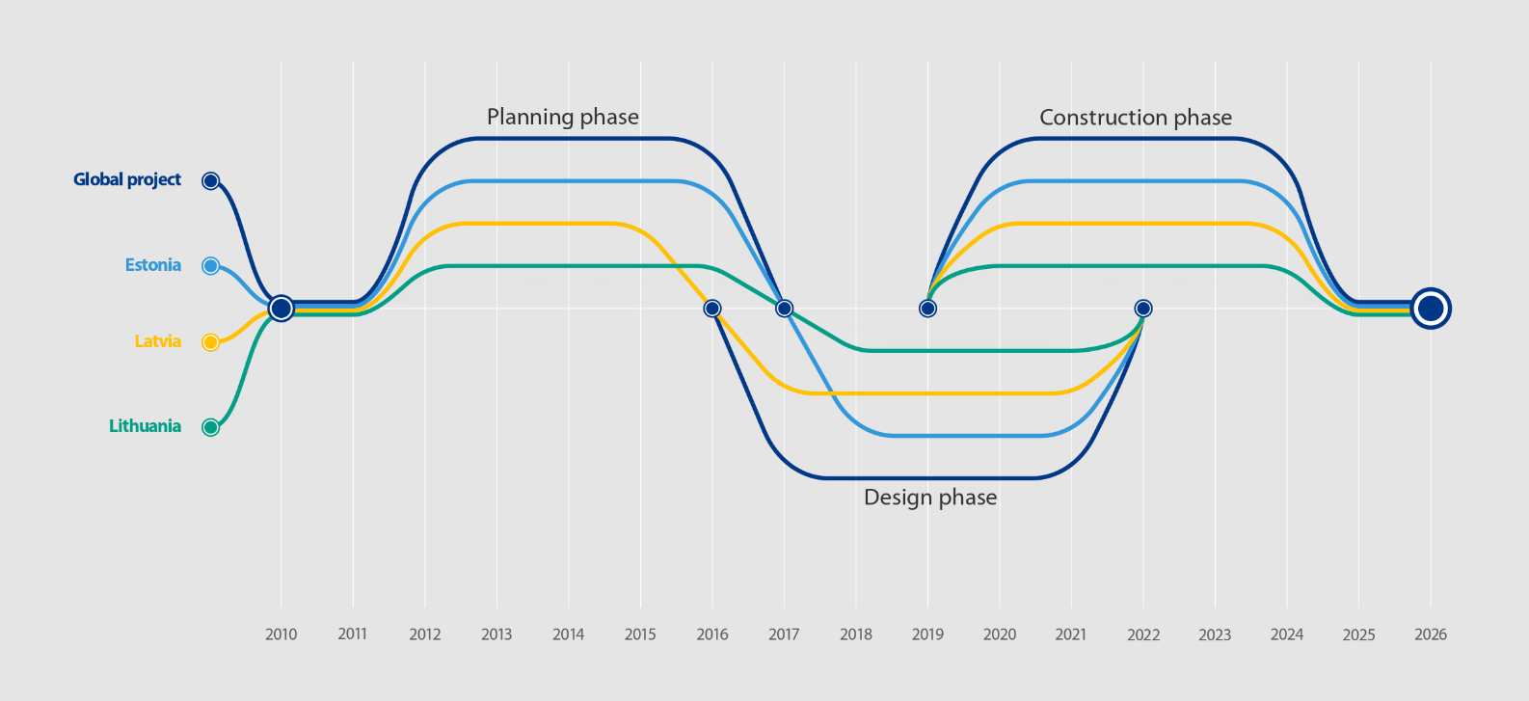

RB Rail AS is currently structured as follows:

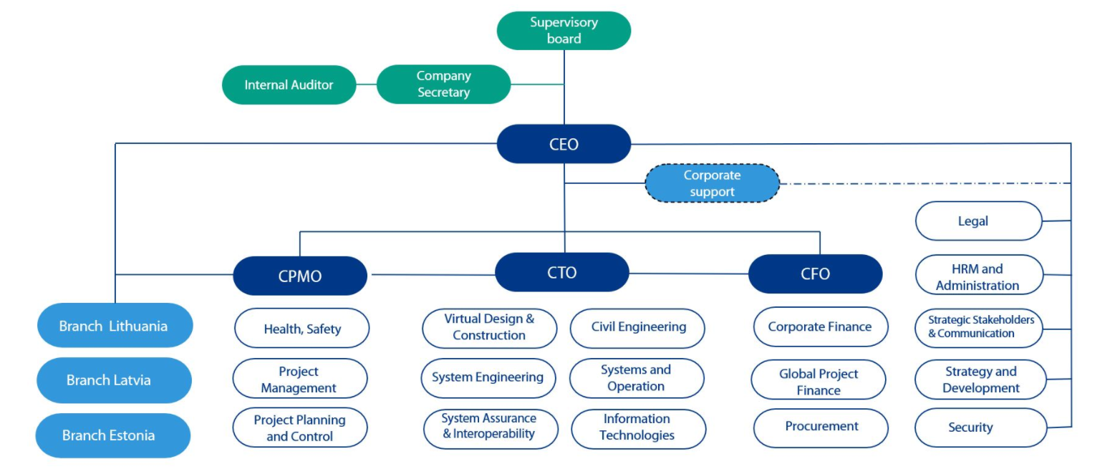

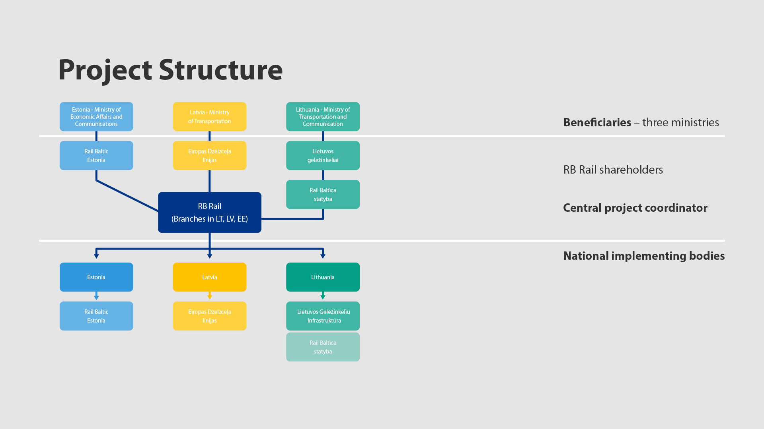

For more information on RB Rail AS, the Global Project, and Rail Baltica, please see https://www.railbaltica.org/about-rail-baltica/documentation/ .

Project Overview
RB Rail AS recognizes the opportunity it has in respect of a ‘greenfield’ rail environment and wishes to define its long-term IT Strategy based on EU and global best practice from the rail industry and the wider multimodal mobility and logistics ecosystem. As part of the overall operations of the railway, Rail Baltica will rely heavily upon an integrated technology and business environment to manage the tendering, contracting, construction project management, cost control, handover, train operations, multimodal integration, customer management, supplier management, billing, maintenance, back-office support functions and so on. As RB Rail AS is building a ‘greenfield’ railway, it is critical to take advantage of the opportunity to establish a fully integrated solution landscape and avoid the common integration challenges faced by railways today.
The primary objective of this project will be to provide RB Rail AS, the future owners of the infrastructure, and the Implementing Bodies with a long-term IT Strategy based upon the current and evolving RB Rail AS operating model (the Implementation Stage) and the future Rail Baltica operating model (the Operations Stage), and associated business processes for each Stage.
The IT Strategy will be delivered in two stages (to be elaborated upon in subsequent sections):
- Implementation stage
- Operational stage

RFP Purpose

The intent of this RFP is for RB Rail AS is to identify the most suitable organisation to work with them in defining the long-term IT Strategy for RB Rail AS and Rail Baltica to include:
- Working collaboratively with all stakeholders of the IT Strategy, to ensure RB Rail AS and Rail Baltica business goals and requirements are accurately acknowledged, defined, and addressed across the full breadth of the business
- A workable and fully risk-managed solution, that can adapt and scale as the RB Rail AS and Rail Baltica operating models develop, and the business grows, aligned with and supporting the Rail Baltica Master Schedule
- Strong alignment to key principles:
  - Follow EU and global best practice
  - Follow relevant EU and global standards
  - An integrated Enterprise Architecture for Rail Baltica – one railway, one system, one operating model, one set of rules and standards
- Strong alignment of the operating model processes and IT systems to increase productivity, business agility and return on investment.
- Streamlined business processes to reduce the procedure cycles and increase rail operational effectiveness and efficiency.
- Full inclusion of the business, data, applications, technology, and IT Security domains
- A strong and best practice focus and inclusion of IT Security management throughout the strategy and the architecture
- Defined functionality between applications and standardisation of application integration interfaces to improve visibility, interoperability, and integration of systems.
- Integrated reporting capability and easy access to high quality, trusted information for all users, for effective decision making.
- Reduced application design and development costs and technology risks aided by using standardized reference architectures.
- An approach to information management that will allow the successful transition of a capital delivery project to an operational railway with minimum disruption.

Objectives

The primary objective of this project is to provide RB Rail AS, the future owners of the infrastructure and the Implementing Bodies with a long-term IT Strategy based upon their respective current and evolving operating models and business processes.
This includes reducing risk in all aspects of achieving the mission of RB Rail AS and Rail Baltica, including:
- Development and delivery of the IT Strategy in two stages:
  - Implementation stage
    - Supporting the Global Project
    - General corporate support functions
    - Core project implementation functionality
    - Handover to Rail Baltica operations
  - Operations stage
    - Inclusive of Global Project capabilities
    - Handover from the Global Project
    - Rail Baltica business operations
- Development of the IT Strategy in a synchronised manner and with effective project control
  - Including IT tools for stakeholder management, project controls, project reporting so that the status and progress of development of the IT Strategy is clear
- Effective and efficient business processes supported by aligned, effective and efficient IT
- Defining requirements of the Control Command and Signalling (CCS) subsystem and its interfaces to align the CCS solution, operational and safety critical applications (Traffic Management System, Interlocking, ERTMS, etc..) with the long-term IT strategy.
- Providing access to up-to-date information under emergency conditions.
- Ensure information and tools interoperability during all project development phases for all project Companies to follow using the same set of tools and processes.
- Ensuring data systems integration with other infrastructure managers, operators, and service providers in the context of the wider multimodal mobility and logistics ecosystem, including non-rail infrastructure organisations and operators.
- Setting unified standards and guidelines for IT systems and data system interoperability, including but not limited to the following examples:
  - Rail Baltica Design Guidelines
  - Open standards and data where possible
  - ERA TSIs (e.g., INF, CCS, ENE, TAF, TAP TSIs)
  - Appropriate Shift2Rail and related deliverables, including but not limited to
    - LINX4RAIL “System architecture and Conceptual Data Model for railway, common data dictionary and global system modelling specifications”
  - RFC8 standards e.g., for Path Requests
  - Unified Security standards across the current and future organisation, including from ENISA
- Reducing supplier risk, using standardised data interfaces.
  - Many such interfaces have been developed under Shift2Rail, and this activity shall address the timelines and readiness of key areas such as the Conceptual Data Model for use in Rail Baltica, together with ensuring potential benefits of digitalisation are not obstructed by barriers between systems.
- The IT Strategy Roadmap and Plan provides for implementation of the project in a synchronised manner and with effective project control and quality management
  - Including IT tools for stakeholder management, project controls, project reporting so that the status and progress of implementation of the IT Strategy is clear
- Holistic management of IT security aspects
  - The cyber security management of Rail Baltica's railway IT and IT infrastructure has not been addressed so far and, given the cross-border nature of Rail Baltica's railways, the cyber security strategy must
    - Be embedded throughout the IT Strategy and Enterprise Architecture
    - Include guidelines and a governance model that is synchronized in all Rail Baltica's railway infrastructure countries and meets EU and national cyber security requirements.
    - Address cyber security for operational and safety critical applications of the CCS subsystems: Traffic Management System, Interlocking, ERTMS

PROJECT SCOPE

Scope of Work

RB Rail AS recognizes that an integrated Enterprise Architecture will play a critical role in realising its future growth and expansion plans and those of the owners of the built infrastructure, as Rail Baltica moves into operations. The IT Strategy scope is to develop a framework for the (separate) implementation of a secure, optimized, and seamlessly integrated business, information, and technology framework with a significant focus on best practice in the rail industry and wider mobility and logistics industry.

Note that the Enterprise Architecture is expected to evolve from an architecture that supports the requirements of the Global Project (design and build) organisation, through defined stages, to one that supports the future Rail Baltica operational model, with the probability that capabilities from the Global Project will be carried forward and integrated into the Target Enterprise Architecture that fully supports the future Rail Baltica operating model.

The scope of this project is to develop an IT Strategy including an Enterprise Architecture for IT to help meet the goals of the Global Project and Rail Baltica future operations, and a plan for the Global Project to (separately) implement, that are in full alignment with the business vision and mission. All requirements should be considered over the lifecycle of the project and subsequent business operations i.e., development, commissioning, and subsequent go live and running of phased rail operations and other business operations such as, operation of freight terminals, commercial space development in/around stations, dark fibre services (along the RB corridor) etc.

The journey through completion of the current implementation project, commissioning, and handover and into future operations will be supported by an aligned IT Strategy delivered in two main stages for RB Rail AS Global Project Implementation and Rail Baltica Operations, respectively.

There is a significant risk that the agreed future Operating Model for Rail Baltica (the Operations Stage) will be unavailable for the start of the IT Strategy development work (including for the development of the IT Strategy for the Operations Stage). At the time of writing there is no confirmed expected date for availability. Therefore, the agreed Operating Model is a key dependency for development of the IT Strategy for the Operations Stage. RB Rail AS will provide the most up-to-date information available to the selected supplier, prior to availability of the agreed Operating Model, and the agreed Operating Model once available.

To mitigate the risk/issue of delayed availability of the agreed Rail Baltica Operating Model, the proposed approach is required to be as follows:

- Initially, if the agreed Operating Model is not available, develop the IT Strategy up to a Transition stage incorporating an Enterprise Architecture that can flex to support known / expected options for the Operating Model
  - The Infrastructure Management Study, 2019 provides background on relevant options for the Operating Model (note none of the options or recommendation(s) in the study are approved at the time of writing)
- Once the agreed Operating Model is known, the IT Strategy for the Operations Stage can be completed, building on the flexible Enterprise Architecture
- If the agreed Operating Model is available in time for development of the IT Strategy for the Operations Stage, the work does not need to be phased as outlined in the previous bullets
Below is a high-level representation (based on TOGAF) of how RB Rail AS view the Enterprise Architecture and how it will drive business value.

Enterprise Architecture (scope and structure of design and specification)

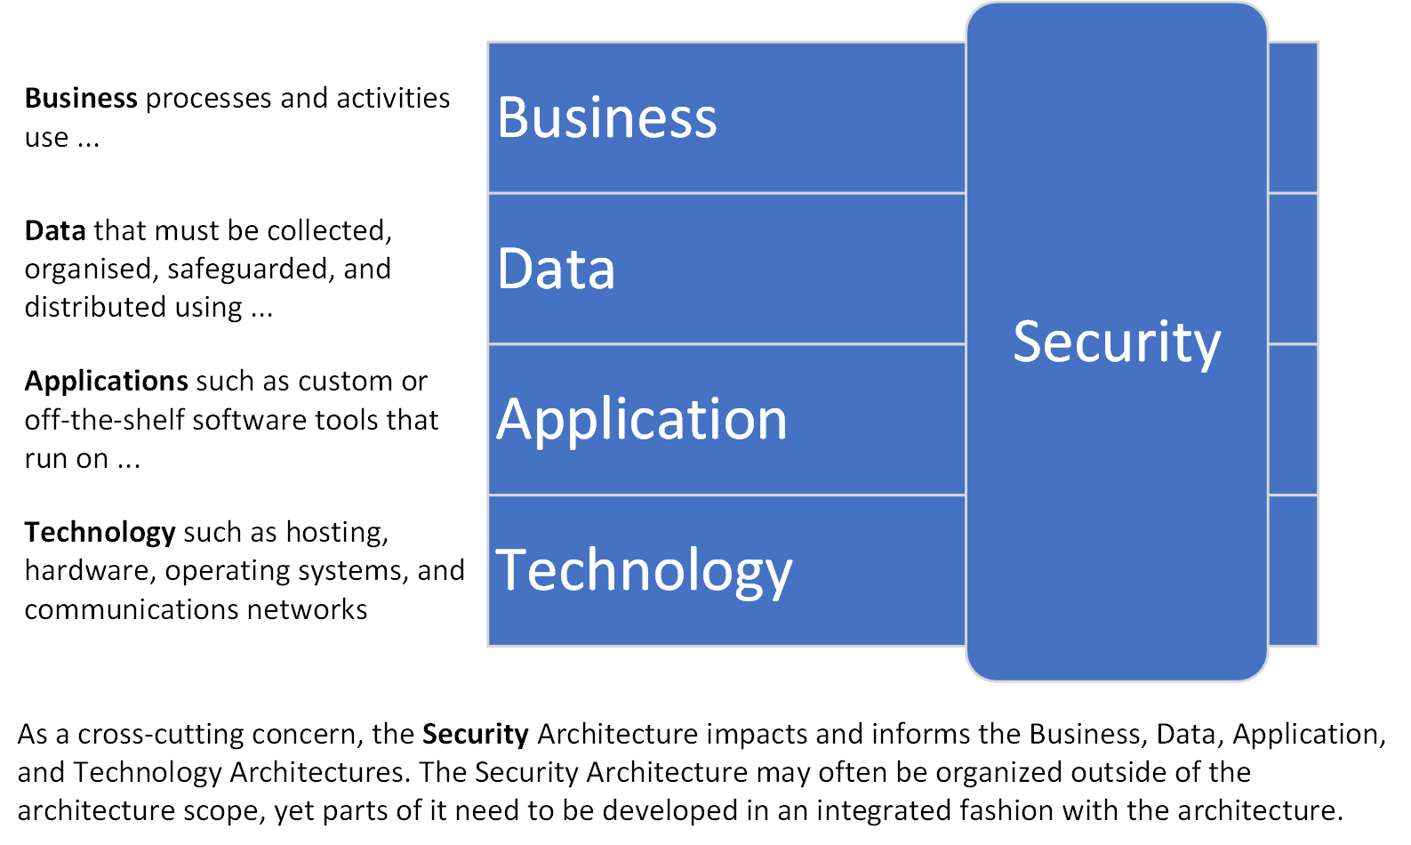

The proposal must state and describe the proposed ADM to be used in development of the IT Strategy, and whether it is proprietary or can be reused by RB Rail AS / Rail Baltica as part of a future Enterprise Architecture capability. See the Deliverables section, under “Provide Recommendations to Establish Enterprise Architecture Capability”.

RB Rail AS and Rail Baltica have a significant opportunity as a ‘greenfield’ infrastructure relatively (see e.g., As-Is systems) unhindered by legacy applications and technology. As such, it is expected that the successful bidder will display in depth knowledge of state-of-the-art, EU and global practices and standards (including from the rail industry and, where appropriate, beyond) and will be able to leverage through benchmarking an IT Strategy that identifies and incorporates lessons learned from elsewhere to drive long term benefits and efficiencies.

The following sub-sections address expected activities and tasks to develop the IT Strategy. This is not intended to be exhaustive.

Benchmarking and Best Practice

It is expected that the project will involve a level of benchmarking to understand leading practice for European and global rail operators in line with the proposed RB Rail AS and Rail Baltica target operating models.

- Analyse other infrastructure projects from across the EU/world, with relevance/similarities to the Rail Baltica project, to understand best practices used and lessons learned
  - Provide and explain resulting recommendations for Rail Baltica’s IT Strategy
It is expected that the project will identify and consider key technologies and technology developments from within the Rail industry and beyond to understand those that can be leveraged by RB Rail AS and Rail Baltica to gain strategic advantage in meeting business goals. Appropriate technologies and how they may be applied is open and consideration should be undertaken in collaboration and consultation with the stakeholders including RB Rail AS Strategy and Development team and the IBs. These technologies may include, for example:

- Advanced Business Intelligence and data analytics
- Digitalisation of information and data
- BIM/Common Data Environment
- 5G and related areas
- Advanced technologies for condition monitoring
- Asset/component tracking throughout lifecycle
- Etc.
It is also expected that the risks versus potential rewards will be evaluated with the key stakeholders when considering any new technology for inclusion in the architecture, as well as the cumulative risk of adopting multiple new technologies, should this be proposed.

Collaborative Working

It is critical for the supplier to work collaboratively with all stakeholders of the IT Strategy and Enterprise Architecture, to ensure RB Rail AS and Rail Baltica business goals and requirements are accurately acknowledged, defined, and addressed across the full breadth of the business, including but not limited to
- RB Rail AS/Global Project Executives and their respective designated representatives for each department and national office
- National Beneficiaries/national Implementation Bodies and their respective designated representatives
- Designated representatives of key external stakeholders as required, including Construction Contractors, Rail Undertakings (RUs), Multi-mode transport connections (Ports, Airports, etc.), Emergency Services, Customers, Suppliers, Governments, Government Agencies (such as Tax/Customs), Regulators, and other entities which require integration.
While working collaboratively, the IT Strategy developer is expected to retain intellectual autonomy. Where stakeholders take different views on aspects of the strategy the IT Strategy developer should work for an optimised decision on how to proceed, with escalation to senior management of RB Rail AS, with recommendations, where differing views of stakeholders have not been reconciled.
Analyse strategies, initiatives, tenders, plans, projects etc., that relate to the IT Strategy, that have been/are being developed or executed by various stakeholders from across the business to understand, agree and define how they can be aligned with the IT Strategy, taken as inputs, and managed for interdependencies with “gives and gets” to and from the IT Strategy. This should include the following examples:
- CCS Design and Build project (see the CCS subsystems breakdown structure in the Appendix)
- ENE Design and Build project
- Cyber Security
- Document Management Strategy
- BIM Strategy (incl. Asset Register)
- Digitalisation (including BIM, CDE work)
- Strategy and Development (e.g., Data Strategy, Digitalisation, Integration approach)
- Individual national Implementing Bodies’ IT Strategies, Business Plans and Business Change Plans relating to Rail Baltica
- Shadow Operator
- Data Centre/Hosting status – (future architecture has been not determined and is within scope of the IT Strategy)
Create and implement a communications plan.

Architecture Vision

Document the Architecture Vision including details such as mission, strategy, stakeholder objectives, challenges, and envisioned architecture model
The Architecture Vision should be developed at a high level to allow senior management buy in. It is expected that this Vision will be the basis for the other deliverables.
Develop preliminary Enterprise Architecture Principles for RB Rail AS and Rail Baltica, across all architecture domains (i.e., Business, Application, Data, Technology, and IT Security) – to be refined in the separate architecture domains work

Baseline (As-Is) Architecture

RB Rail AS is a relatively young organisation and as such the as-is architecture definition is not as extensive as in mature railway organisations; however, it is not static and is evolving in several areas – for examples, see the section on Collaborative Working.
Review the Baseline Architecture by studying relevant aspects of the current state business functions, services, process maps, information flows, data models, application systems, application integration Interfaces, infrastructure, network, hardware systems, software products, etc.
- This applies to RB Rail AS and aspects of the national Implementation Bodies current IT estates that are relevant to the Rail Baltica architecture, including systems used for the delivery of their projects
  - As per the guiding principle of “An integrated Enterprise Architecture for Rail Baltica – one railway, one system, one operating model, one set of rules and standards” – IB systems will not automatically be used for Rail Baltica, but can, where needed, be integrated with the Rail Baltica system(s) after implementation of the core Rail Baltica Enterprise Architecture
- Also applies to managers of related infrastructure that will require interfaces such as airports and seaports and other external parties
Analyze all currently implemented systems and planned to be implemented systems at a Global Project level

- Develop specification and requirements for future development of the IT systems

As-Is Technology Architecture – RB Rail AS

The following list (not exhaustive) describes the current state technology and applications structure for RB Rail AS:

- Hosting is primarily provided by Microsoft Azure with some locally hosted technical infrastructure including servers, network connectivity with Microsoft Azure cloud backup
- User access management – Microsoft AD, Uniflow
- Office 365
- MS Teams, MS Planner, MS Project
- Document Management – SharePoint, DocLogix, Bentley ProjectWise, Trimble Connect
- Autodesk tools including AutoCAD
- ArcGIS
- Oracle Primavera P6 for project planning and management
- Oracle Cloud for Risk Management
- Railsys
- Microsoft Power BI, and other systems

As-Is Technology Architecture – IBs

The IT Strategy will provide clear analyses of all currently implemented systems and planned to be implemented systems of the IBs (where relevant to Rail Baltica).

Transitional and Target Architectures

A Transition Architecture is an intermediate architecture at a specific point in time, short of attaining the full Target Architecture that meets the totality of requirements. One or more Transition Architectures may be used to describe the progression in time from the Baseline to the Target Architecture.
The purposes of the Transition Architecture(s) may include:
- Sufficient Architecture development to meet interim (phased) business goals – an example of this could be capabilities to support fully scaled construction contractor management, document management and handover capabilities in sufficient time for testing before the relevant business milestones are reached for the Implementation Stage, and prior to delivery of further Transition Architecture(s) and the full Target Architecture of the Operations Stage.
- Risk Management – breaking down the total scope of work into manageable phases
Design and develop the Transitional and Target architectures to support RB Rail AS’s and Rail Baltica’s Long Term Architecture Vision, Business Plans and Master Schedule for all Enterprise Architecture domains through proposed business services, process maps, information flows, infrastructure, network, hardware systems, software products, etc (i.e., Future Business Architecture, Application Architecture, Data Architecture, Integration Architecture, Technology Architecture, and IT Security Architecture).
Development of the Transitional and Target Architectures should also include:
- Identify opportunities and set the guidelines/best practices to optimize the business processes, information flow, and data life cycle within RB Rail AS and Rail Baltica.
- Define standards and guidelines for integration with operational solutions delivered as ‘turnkey’ as part of CCS and ENE design and build projects e.g., SCADA, Asset Protection Systems, CCS, Power Management, etc.
- Specify/define standards and guidelines to be used (when the IT Strategy is separately implemented), in conjunction with the Enterprise Architecture Principles for selection of relevant software products and hardware systems.

Business Architecture

The Business Architecture describes how the enterprise needs to operate to achieve the business goals and respond to the strategic drivers set out in the Architecture Vision.

Key in-scope functions and capabilities of the desired Enterprise Architecture include (but are not limited to – full scope is expected to emerge from Enterprise Architecture gap analysis etc.):

- Implementation Stage: Design, Build, and Deliver Rail Infrastructure and Rail Systems e.g.
  - Back Office (including CPMO Project Management, Project Planning & Control, Reporting etc.)
  - Network and Capacity Planning
  - Customer Management (including Customer Relationship Management throughout the project implementation stages of IBs)
  - Enterprise Resource Planning
  - Tendering
  - Contracting
  - Construction project management
  - Cost control
  - IT information systems implementation and management (data and applications)
  - Document Management
    - Effective Document Management is required to support all functions and capabilities, throughout the lifecycle of RB Rail AS and Rail Baltica.
  - Building Materials Laboratory Inspection and Testing to ensure material properties compliance disclosed within EN Eurocodes and national technical specifications.
  - Handover to Operations
- Operations Stage: Implementation Stage capabilities carried forward and enhanced as needed, plus Operational Rail Processes E.g.
  - Asset Management
  - Pricing
  - Sales and Order Management
  - Train Operations (Train Operations design and build is mostly from CCS project scope, but business process definition is within IT Strategy scope)
  - etc.
- Operations Stage: Integration with Rail Systems and CCS systems delivered via the CCS and ENE Design and Build projects, including (also see the CCS subsystem breakdown structure in the Appendix):
  - Communications Systems (Data backbone, network design, PA/VA, Clock, Telephones, Voice Recording, Radio etc.)
  - Depot Equipment (for maintenance)
  - Fire Systems
  - Asset Protection Systems (hot bearing detection, weigh in motion etc)
  - Mechanical and Public Health (HVAC)
  - Meteorological System
  - Control Centre Systems / Control, Command and Signalling (CCS) systems
  - ENE
  - SCADA
  - Security Systems (CCTV, Access Control)
  - Etc.
- Implementation Stage and Operations Stage as needed: Integration with external systems as needed for Construction Contractors, Rail Undertakings (RUs), Multi-mode transport connections (Ports, Airports, etc.), Emergency Services, Customers, Suppliers, Governments, Regulators, and other entities which require integration
- Etc.
Business process mapping will be required to define the IT Strategy. This is not expected to be a full business process mapping exercise in every area, but detail mapping is required for key processes. There does not currently exist a full business process map for the organisation. The key ‘back office’ processes for Finance, HRM, Programme Management, and Procurement are defined through the organisation ‘Policies and Procedures’. These will be made available to the successful bidder during the project.

It is expected that all business processes of RB Rail AS and Rail Baltica will be mapped to Level 1. Indicative business processes can be found in Appendix 1. Note: These are indicative and are defined to assist the bidder in understanding the levels required. The successful bidder is expected to identify the numbers of processes required and justify these levels in their technical proposal.

It is expected that several business processes will require definition to Level 2 or 3 to fully understand the subsequent information, integration, and technology requirements. Again, indicative processes are defined in Appendix 1. The bidder is expected to understand where the priority lies for these processes and bound their technical proposals accordingly.

Data Architecture

The scope is both Data (“structured information” as typically used by systems) and Information (“unstructured information” as typically used by people).

This activity includes developing a description of the structure and interaction of the enterprise's major types and sources of data, logical data assets, physical data assets, and data management resources.

Assess the readiness of the Shift2Rail Conceptual Data Model and related standards for use by Rail Baltica

- Consider alignment of these standards with Rail Baltica’s CCS developments
- Examine the consistency and readiness of approaches to data in different Shift2Rail projects and how such data standards can be used to minimize risk during delivery and maximize flexibility over the full lifecycle, as inputs to specifications and requirements for system implementation.
- Ensure that the demarcation of systems into operational technology (control systems) and information technology does not create unnecessary barriers to appropriate information flow, including providing and managing secure access to information for emergency services/agencies & first responders.
Data asset management over the full lifecycle of data from acquisition to retirement is critical to ensure that all data processed by systems and accessible to users as information, is high quality and trusted. High quality, trusted data supports effective Business Processes and Decision Making as well as user acceptance of systems.

Understand and document the key information flows and requirements for construction, handover and running of an operational railway. This should drive the high-level definition of an Enterprise Data Warehouse and/or usage of appropriate shared EU/industry Data Warehouse and how future business benefits can be leveraged through analytics and Business Intelligence. Information Management and Analytics are key to the long-term efficient operations of the railway in a significant number of areas e.g., Pricing, Scheduling and Planning, Maintenance Scheduling, Performance Analysis etc.
Other aspects of Information management that must be addressed include:
- Enterprise Content Management covering such areas as the Rail Baltica BIM Strategy, Document Management, and Web Content Management
- Business opportunities for private companies deriving from the Open Data concept and information flows between Rail Baltica and the companies

Application Architecture

It is expected that this activity will focus on developing the descriptions, specifications, and requirements for software applications that enable the Business Architecture and the Architecture Vision, align with the Data Architecture and hence
- Identify candidate IT Strategy Roadmap components based upon gaps between the Baseline and Target Application Architectures
  - As-Is (baseline) Application Architecture (high level except where applications are expected to be carried forward into Transitional/Target Architectures)
  - Transitional Application Architectures
  - Target Application Architecture
- Modular Solution Building Blocks (SBBs), or re-usable solutions for future implementation efforts, should be defined with sufficient detail to support future procurement/selection of specific solutions and products, and with flexibility to replace specific solutions within the modular architecture if and when this becomes necessary
- Map and provide an integration plan for the solutions currently used in each of the project implementation partners across the Rail Baltica Global Project, and define integration specifications and requirements

Integration Architecture

As Rail Baltica aspires to become the centre of the NE Europe mobility and logistics network, it is paramount that the IT Strategy should deliver a solution based on principles of easy accessibility to and integration with information systems of major stakeholders across the network.

The delivery mechanism for RB Rail AS’s and Rail Baltica’s architectures will require significant integration and information flows during the project and operational lifecycle. The IT Strategy project is expected to recommend reference architectures to securely support secure, technology independent integration across the enterprise.
Secure and standardised integration and interoperability is required between all areas of the Enterprise Architecture without barriers from demarcation resulting from various sources of the components, such as the CCS, ENE, and IT Strategy contracts, scopes, and suppliers.
Scope includes integration
- Between RB Rail AS Systems (internal integration)
- Between RB Rail AS and external entities (external integration)
- Between national Implementing Bodies (during the infrastructure delivery phase) (internal integration)
- Between RB Rail AS, infrastructure owners (the States) and the future infrastructure manager(s) during project handover and related activities (handover integration)
- Between Rail Baltica Systems (internal integration)
- Between Rail Baltica and external entities (external integration)

Internal Integration

Internal integration is all integration required between RB Rail AS / Rail Baltica systems within
- the Baseline/As-Is Application Architecture
- each Transitional (To-Be) Application Architecture
- the Target (To-Be) Application Architecture

External Integration

External integration is all integration required between

- systems within the Application Architectures of RB Rail AS and Rail Baltica, and

- systems of external parties such as Construction Contractors, RUs, Multi-mode transport connections (Ports, Airports, etc.), Emergency Services, Passengers, Customers, Suppliers, Governments, Government Agencies (such as Tax/Customs), Regulators, Public Transport, and any other entities which require integration to meet the business goals of RB Rail AS/Rail Baltica.

Handover Integration

Handover integration is all integration required for the special purpose of handover of railway design and build deliverables to live operations. This is expected to fully support the handover from the Global Project to Rail Baltica, and future railway infrastructure enhancement projects carried out by Rail Baltica after the handover.

Technology Architecture

This activity is focused on describing and defining the structure and interaction of the technology services and technology components, including

- Data centre and hosting services
- Hardware
- Operating Systems
- Middleware
- Physical Communications Network
- Communications Network Design
- Etc.
Develop the Baseline, Transitional and Target Technology Architectures that enable the Architecture Vision and respective Transitional and Target Business, Data, and Application building blocks to be delivered through Technology components and Technology services.

Data centre and hosting services

The data centre and hosting components of the Technology Architecture must be developed as part of the enterprise architecture. This must include hosting for all IT across RB Rail AS and Rail Baltica, including IT and OT (e.g., CCS, ENE) components.

Communications network

The CCS project scope includes fibre backbone, infrastructure and network design for CCS and Railway Systems (see the indicative CCS subsystems breakdown structure in the appendix).

The IT Strategy is required to build on the core network physical architecture from the CCS project and extend the design to the whole enterprise architecture, i.e., all corporate and operational IT/OT corporate systems across the enterprise. Therefore, for the communications network there are key dependencies between the IT Strategy development (as well as separate and subsequent implementation) and the CCS/ENE Design and Build projects.

Security Architecture

Develop a common optimised Rail Baltica railway cyber security strategy, guidelines and common cyber security governance model, organizational design, policies, regulations, and procedures to support the strategy.

- Examine Cyber Security strategies, EU and national regulations and standards, cyber risks, and best practice in Railway infrastructure in the EU and input findings into an optimal Rail Baltica IT Security strategy. This includes

  - ENISA guidelines and recommendations for railways
  - TEN-T security priorities and practices
  - Dual Use aspects (Military Mobility)
  - Rail Baltica project member states' national security interests and cross-border infrastructure needs
  - Operational and safety critical applications
  - Interfaces with other infrastructure managers and operators
IT Security/Cybersecurity is to be addressed throughout the IT Strategy and Architecture. Areas addressed should include (but are not limited to):

- Risk management strategy
- Threat analysis
- Overarching and integrated Security Architecture covering Business, Data, Application, and Technology domains
- Security use-case models
- List of applicable and to be complied with, security standards including EU and national legal enactments, security means, requirements for IT critical infrastructure
- Cooperation/communication with competent national authorities in IT security field
- Information classification report (to classify information as Confidential, Public, etc. so that rules for protection can be clearly defined and applied)
- List of asset custodians
- Disaster recovery and business continuity plans, crisis management
- Operational and safety critical applications
- External interfaces
- Multi-layered cyber security approach
- Data storage approach and data transmission network model
- Early attack detection, suspicious activity monitoring within hosts and networks
- Physical security (of IT and Cyber Security assets)
- System segregation
- Ecosystem mapping/ecosystem relations
- Human resources security
- Security audits
Note that IT Security requirements for the CCS and ENE design and build projects are also within the scope of the IT Strategy – these are interdependencies that must be reflected in the implementation plan.
Vendor must demonstrate comprehension of the Technical Specification CLC/TS 50701 “Railway applications – Cybersecurity” (published on July 2021), that addresses the application of the widely accepted IEC 62443 standard “Security for industrial automation and control systems” to rail sector.
As railway systems are designed to be used for decades, vendor must address developments in the field of quantum-secure cryptography.

IT Strategy Roadmap and Plan

The IT Strategy Roadmap and Plan address migration planning. That is, how to move from the Baseline to the Target Architecture (from the Implementation Stage to the Operations Stage as well as within each stage) by finalizing a detailed Implementation and Migration Plan for the Implementation Stage and the Operations Stage respectively. For clarity, note that the Roadmap is expected to be an abstracted view of the separate and aligned, detailed Implementation and Migration Plan.
The timeframe of the Roadmap and Plan is expected to be from the current time through the duration of the Global Project (see the Rail Baltica Master Schedule) and for a significant period into the operational running of the railway, following the handover that is planned for 2026 at the time of writing.
The timeframe during which the Enterprise Architecture is fully fit for purpose beyond the handover and into the operational running is open and it is expected that the capabilities that have been implemented with the IT Strategy will support Rail Baltica well beyond this date. A date beyond the handover should be recommended for a review of the Enterprise Architecture.
The IT Strategy must be designed to support Rail Baltica well into the period of operational running and this will require RB Rail AS / Rail Baltica to provide, as a key input to the IT Strategy, the agreed Operating Model and Business Plans for Rail Baltica over the period.
There is a significant risk that the agreed future Operating Model for Rail Baltica (the Operations Stage) will be unavailable for the start of the IT Strategy development work (including for the development of the IT Strategy for the Operations Stage). At the time of writing there is no confirmed expected date for availability. Therefore, the agreed Operating Model is a key dependency for development of the IT Strategy for the Operations Stage. RB Rail AS will provide the most up-to-date information available to the selected supplier, prior to availability of the agreed Operating Model, and the agreed Operating Model once available.

To mitigate the risk/issue of delayed availability of the agreed Rail Baltica Operating Model, the proposed approach is required to be as follows:

- Initially, if the agreed Operating Model is not available, develop the IT Strategy up to a Transition stage incorporating an Enterprise Architecture that can flex to support known / expected options for the Operating Model
  - The Infrastructure Management Study, 2019 provides background on relevant options for the Operating Model (note none of the options or recommendation(s) in the study are approved at the time of writing)
- Once the agreed Operating Model is known, the IT Strategy for the Operations Stage can be completed, building on the flexible Enterprise Architecture
If the agreed Operating Model is available in time for development of the IT Strategy for the Operations Stage, the work does not need to be phased as outlined in the previous bullets
Design and Develop the IT Strategy Roadmap addressing the RB Rail AS and Rail Baltica objectives, business drivers, and milestones, for the Implementation and Operations Stages respectively.
- Identify initiatives list (Projects/Initiatives Catalogue) to realize the Transition and Target Architectures.
- Estimate high level project cost and schedule for identified projects.
- Provide recommendations regarding the best resource planning approach
- Identify and define priorities and risks.
- Define the dependencies, and document Transition Architecture(s) as required for each stage/transition while accounting for the degree of change the organization can cope with at any one time.
- Include key governance and approval process and milestones (key stakeholders from RB Rail AS, national Beneficiaries and national Implementing Bodies are reviewers)

Governance Framework

Define the Governance Bodies and Structure required to support the IT Strategy development and implementation and provide management visibility into the Enterprise Architecture progression.
Define the skills, processes, and roles & responsibilities required for the governance bodies to achieve their set objectives.

PROJECT DELIVERY APPROACH

Outputs and Results

The primary objective of this project is to provide RB Rail AS, the future owners of the infrastructure and the Implementing Bodies with a long-term IT Strategy based upon the current and evolving RB Rail AS operating model and the future Rail Baltica operating model and associated business processes – the Implementation and Operations Stages respectively.

The IT Strategy will provide clear recommendations (with rationales) based on strong understanding of the best practices in the Railway industry and beyond for systems and technology architecture implementation, and maintenance to ensure Global Project implementation on time and in optimum scope/quality.

The recommendations will be used as an input for the future choice of the systems, as well as technology decisions (including data centre/hosting architecture).

The IT Strategy will provide clear analyses of currently used systems of RB Rail AS and the IBs (where relevant to Rail Baltica) and give recommendations for future integration and unification of tools across the Global Project implementers, thus ensuring implementation of the Global Project on time and acceleration of the project delivery process. The result will be used as input for future tools integration and implementation decisions.

The IT Strategy will provide a standards-based, interoperable, and flexible digitalisation approach using outputs of Shift2Rail and other projects as well as previous Rail Baltica work to enable trusted and efficient information flow between systems and across organisations such as RU(s)/IM(s) in future. This will also assist with seamless & efficient transition of information from the implementation phase to the operational phase.

The IT Strategy will provide a cyber security requirements and governance model for a unified railway infrastructure

Summary of Deliverables

General Deliverables

The list of general deliverables in this section is an indicative high-level summary based on the TOGAF Architecture Development Method (ADM) with some additions; it is not intended to be exhaustive or exclusive. Equivalent work products should be specified at a detailed level and be based on the stated ADM to be followed by the supplier, specifically tailored for Rail Baltica.

In general, these deliverables apply to both the Implementation Stage and the Operations Stage as well as progressively from Implementation to Operations, covering the capabilities needed.

- Architecture Principles, Vision and Requirements
  - Architecture Principles
  - Architecture Vision, e.g.,
    - Business Principles, Objectives and Drivers
    - Business Vision
    - Business Strategy
    - IT Systems Strategy
    - Technology Strategy
    - IT Security Strategy
    - Stakeholders
  - Architecture Requirements, e.g.,
    - Requirements
    - Constraints
    - Assumptions
    - Gaps

- Business Architecture, e.g.,
  - Operating Model
  - Business Architecture Principles
  - Organization structure
  - Business goals and objectives
  - Business services
  - Business processes
  - Business roles
  - Correlation of organization and functions
  - Business continuity and resilience requirements

- Information Systems Architecture
  - Data, e.g.:
    - Data Architecture Principles
    - Business data model
    - Logical data model
    - Data management process models
    - Data Entity/Business Function matrix
  - Application, e.g.,
    - Application Architecture Principles
    - Application Portfolio catalog
    - Interface catalog
    - Application/Organization matrix
    - Role/Application matrix
    - Application/Function matrix
    - Application Interaction matrix
    - Application Communication diagram
    - Application and User Location diagram
    - Application Use-Case diagram
    - Process/Application Realization diagram
  - Integration, e.g.,
    - Integration Architecture Principles
    - Internal Integration
    - Handover Integration
    - External Integration

- Technology Architecture, e.g.,
  - Technology Architecture Principles
  - Data Centre/Hosting
  - Hardware/OS
  - Middleware
  - Communications Network

- IT Security Architecture, e.g.,
  - IT Security Architecture Principles
  - Business
  - Information Systems
  - Technology

- Implementation and Migration Plan, including:
  - Implementation and Migration Strategy
  - Project and portfolio breakdown of the implementation
  - Resource utilisation plan
  - Architecture Roadmap
  - Implementation Governance Model

- Provide Recommendations to Establish Enterprise Architecture Capability
  - Review the organizational context for conducting Enterprise Architecture
  - Identify and scope the elements of the enterprise organizations affected by the Architecture Capability
  - Identify the established frameworks, methods, and processes that intersect with the Architecture Capability
  - Establish Capability Maturity target
  - Define and recommend the Organizational Model for Enterprise Architecture
  - Define and recommend the detailed process and resources for Architecture Governance
  - Recommend tools that support the Architecture Capability
  - Recommend Architecture Methodology / ADM
  - Describe the compatibility of the proposed ADM to be used in the development of the IT Strategy with the recommended ADM

Cyber Security Strategy

Develop a common optimised RB Rail AS and Rail Baltica railway Cyber Security Strategy, guidelines and common cyber security governance model, organizational design, policies, regulations, and procedures to support the strategy.

A preliminary version of the Cyber Security Strategy should be delivered for the Implementation Stage, followed by the all-encompassing version for the Operations Stage.

- This Strategy will have interdependencies with the separate, but related development of a physical railway security strategy, for example
  - Cyber Security Strategy scope includes physical security of IT assets and should align standards, etc. with physical railway security strategy
  - Physical Railway Security Strategy is expected to use various IT Assets to support physical security and should align standards with the IT Strategy

Digitalisation Strategy

Develop a Digitalisation Strategy

A preliminary version of the Digitalisation Strategy should be delivered for the Implementation Stage, followed by the all-encompassing version for the Operations Stage. This work is to be done in conjunction with the RB Rail AS Strategy and Development team.

- Assess the readiness of the Shift2Rail Conceptual Data Model and related standards including alignment of these standards with CCS developments.
- Assess projects such as but not limited to those under Shift2Rail on how such data standards can be used to minimise risk during delivery and maximise flexibility over lifecycle.
- Also consider the EU and Estonia Single Window initiatives
- The strategy will ensure that the demarcation of systems into operational technology (control systems) and information technology does not create unnecessary barriers to appropriate information flow, including providing and managing secure access to information for emergency services/agencies & first responders

Data and Tools Strategy

Develop a Data and Tools Strategy.

A preliminary version of the Data and Tools Strategy should be delivered for the Implementation Stage, followed by the all-encompassing version for the Operations Stage.

Much of the detail of the Data and Tools Strategy is expected to be encompassed within the Data Architecture and Integration Architecture deliverables. However, the Data and Tools Strategy should describe the overall strategy in this area as in the following description of activities and outputs:

Railway/infrastructure projects with similar magnitude and/or aspects will be analysed across the EU/world to understand best practices used, and the analysis developed to provide recommendations on how Rail Baltica project IT strategy and systems can be developed. Also, a task will map and provide an integration plan of the currently used IT solutions in each of the project implementation partners and define common specifications and requirements.

The Data and Tools Strategy will provide clear analyses of currently used systems and give recommendations for future integration and unification of tools across the Global Project implementers, thus ensuring implementation of the Global Project on time, within budget and quality goals, and acceleration of the project delivery process. The result will be used as input for future tools integration and implementation decisions.

Interdependencies with CCS/ENE projects

There are interdependencies both ways between the IT Strategy projects and the CCS/ENE design and build projects that must be addressed in the IT Strategy for the Operations Stage.
The IT Strategy is expected to define requirements for Control Command and Signalling (CCS) and ENE Subsystems and their interfaces to align the CCS/ENE solution, operational and safety critical applications (Traffic Management System, Interlocking, ERTMS, etc..) with the long-term IT strategy.
- This is a dependency from the CCS/ENE design and build projects to the IT Strategy which is responsible for this deliverable
- The design and build (plan) are dependencies from the IT Strategy to CCS and ENE projects (CCS and ENE projects are responsible for deliverables)
- The CCS/ENE design and build projects scope includes Communications Systems (Data backbone, network)
  - The IT Strategy is responsible for the Enterprise Network Architecture, incorporating the CCS/ENE deliverables and extending to the whole organisation (e.g., from the OT scope to the full IT and OT scope of RB Rail AS and Rail Baltica)

APPENDIX 1 Business process definition

Below is an outline of the expected level of business processes to be defined as part of the IT Strategy project and applying to RB Rail AS and Rail Baltica respectively. This is indicative and the Bidder is expected to review this considering their own experience to outline the level of detail required and included within your scope of work.

A subset of the processes should be relevant for the Implementation Stage, and all the processes should be relevant for the Operations Stage (subject to the agreed Operating Model).

Level 0 | Level 1 | Expected 2+ process level definition in specific sub-process areas
Infrastructure and Operations | Manage Capital and Risk
 | Manage Plant, Facilities and Equipment | X
 | Manage Accounting and Control Data
 | Manage Key Accounts | X
 | Manage Maintenance Cycle | X
 | Manage Operation Control Centre | X
 | Manage Train Operations | X
 | Manage Quality and Safety
 | Manage Yard Operations
 | Manage Terminals
 | Manage Sales and Delivery Cycle | X
 | Manage Ticketing and Yield Management | X
 | Manage Data | X
 | Manage IT Security | X
 | Manage Interfaces with external parties (incl. RUs, intermodal IMs, etc.) | X
Construction | Manage Construction Design | X
 | Manage Construction Projects | X
 | Manage Quality Control | X
Back Office | Manage Strategic Planning
 | Manage Legal Services
 | Manage Human Resources | X
 | Manage Administration
 | Manage Finance and Accounting | X
 | Manage Information Technology | X
 | Manage Procurement and Logistics | X
 | Manage Public Relations
 | Manage Service Contracts

APPENDIX 2 Indicative CCS subsystems

The indicative CCS subsystem breakdown structure is provided in the Figure below:
Systems
Interface to civil works
TSI CCS

This approach must be considered; however, the supplier may also propose an alternative approach to mitigate the risk/issue of unavailability of the Rail Baltica Operating Model (with corresponding rationale for alternative approach)
https://www.railbaltica.org/wp-content/uploads/2019/04/RB-AS-Infrastructure-Management-Study-Final-Report.pdf
https://www.opengroup.org/togaf
Process definition level must be detailed enough to develop requirements. Levelling assumptions in this document reflect those described in “Reflections on Business Process Levelling” by S. Viljoen (realirm.com/sites/default/files/whitepapers/reflections_on_business_process_leveling_0.pdf ). Supplier may use alternative levelling if made clear.
This approach must be considered; however, the supplier may also propose an alternative approach to mitigate the risk/issue of unavailability of the Rail Baltica Operating Model (with corresponding rationale for alternative approach)
https://www.railbaltica.org/wp-content/uploads/2019/04/RB-AS-Infrastructure-Management-Study-Final-Report.pdf
CCS design and build is a separate project, but business process definition is not in scope. Business process definition required from IT Strategy project, and harmonisation and interfaces required between IT and OT systems
Potentially in scope together with RUs and CCS project

